PRACTICAL 9 : ENTERPRISE NETWORK DEPLOYMENT AND TROUBLESHOOTING

WEEK 9

Objective
Deploy and troubleshoot a complete Cisco-based enterprise network.

Equipment
- Cisco Routers
- Cisco Switches
- Switch Cabinets
- Patch Panels
- Printers
- 10 PCs

Activities
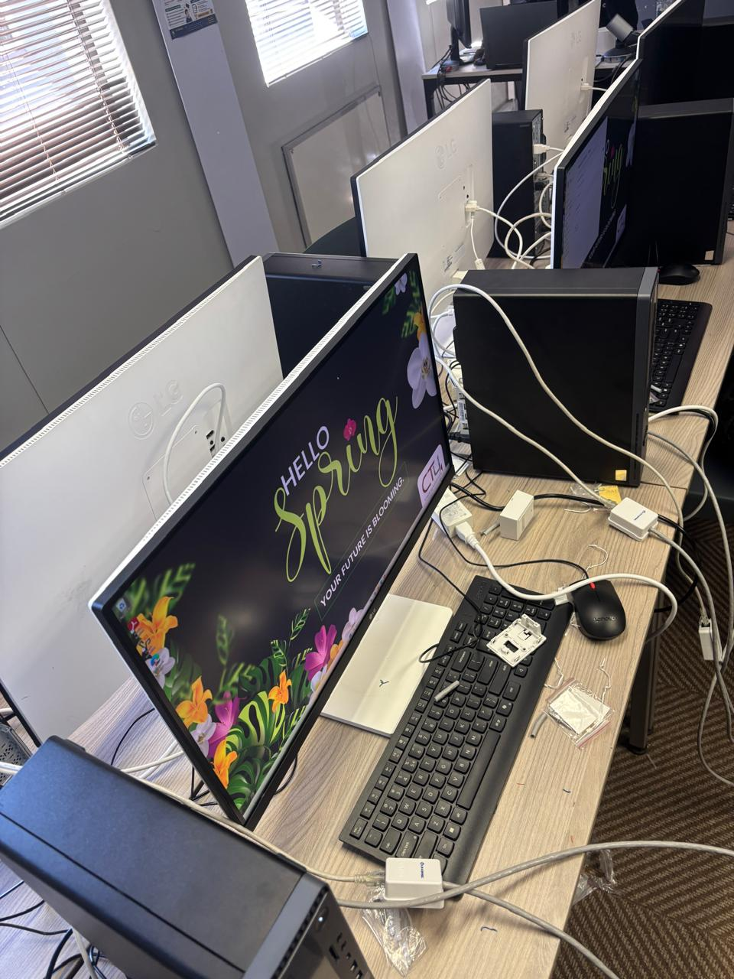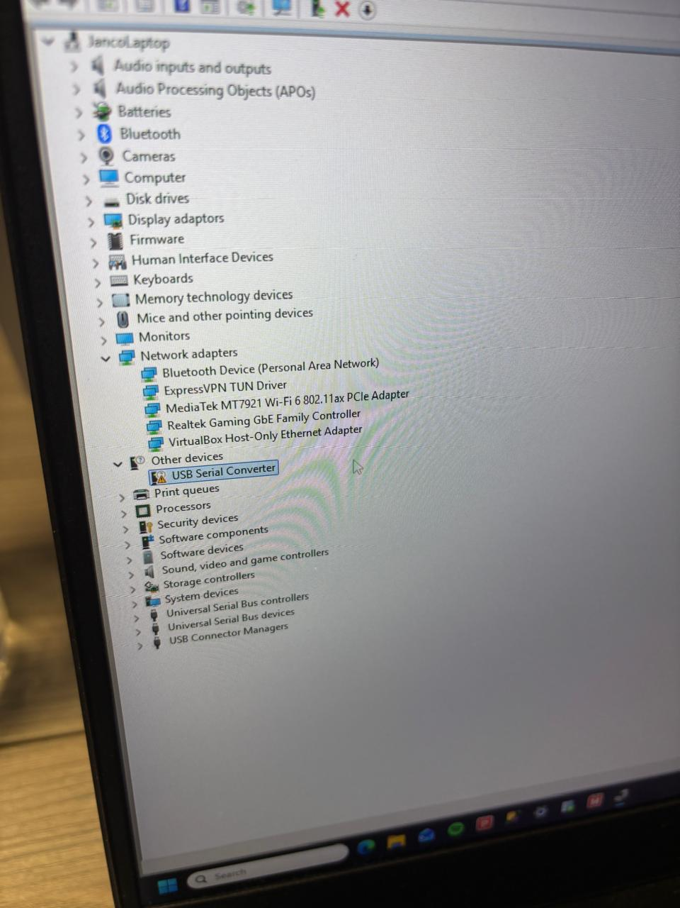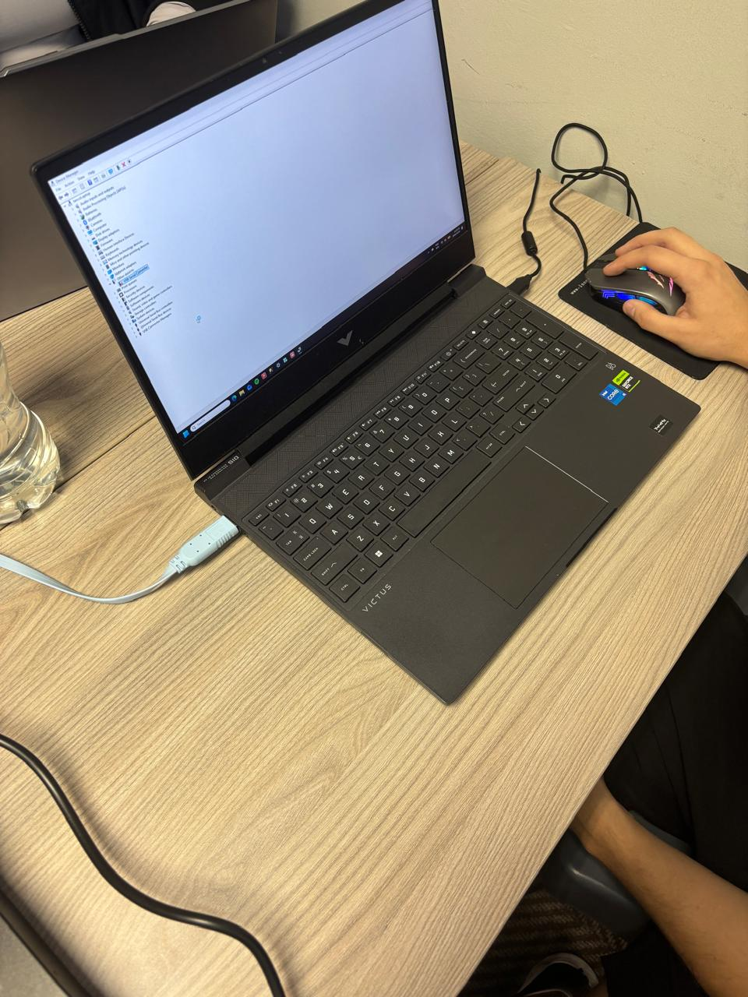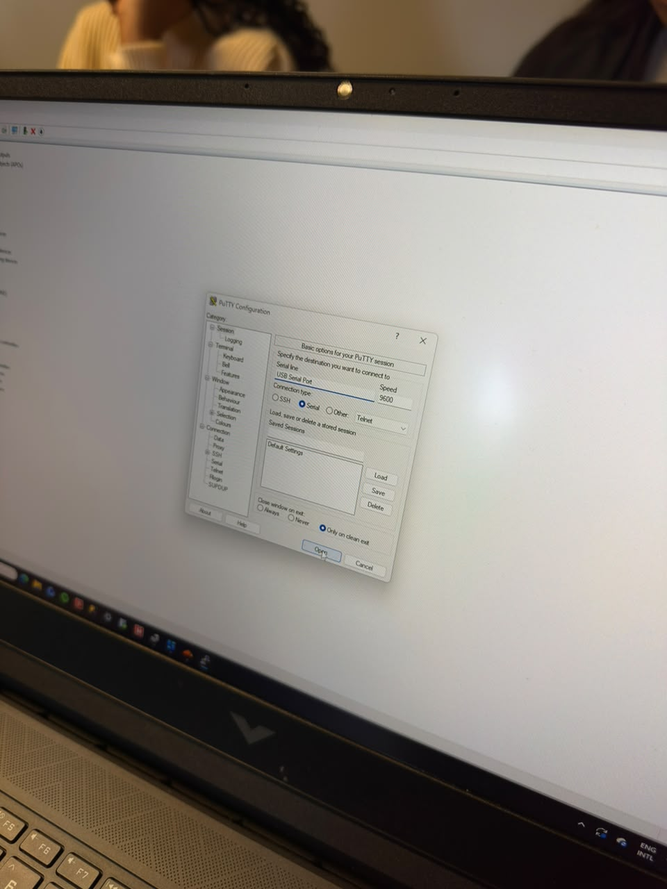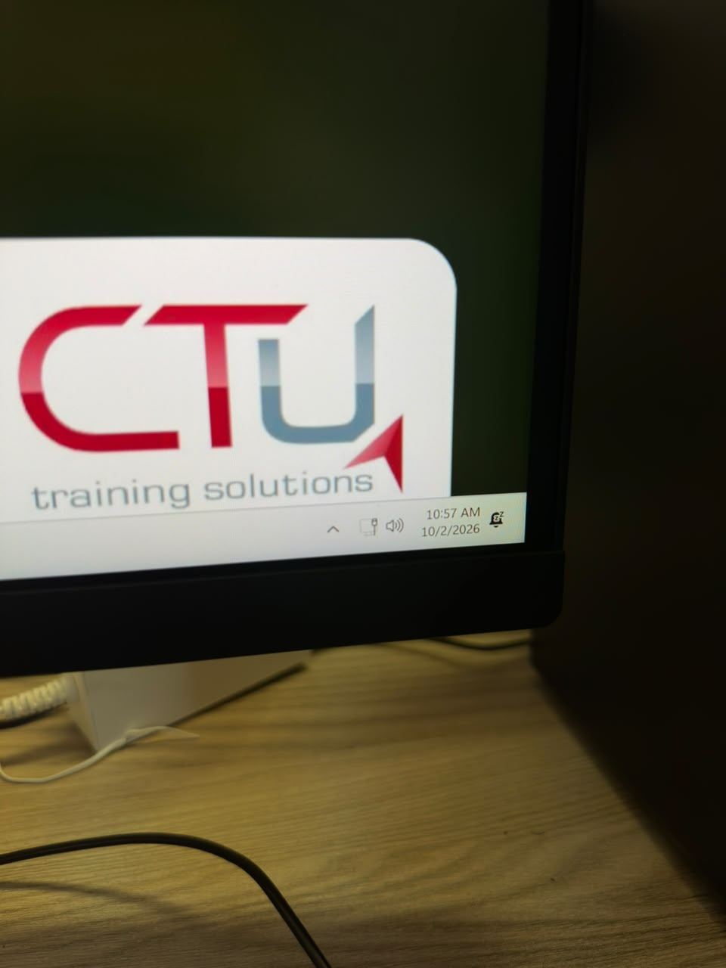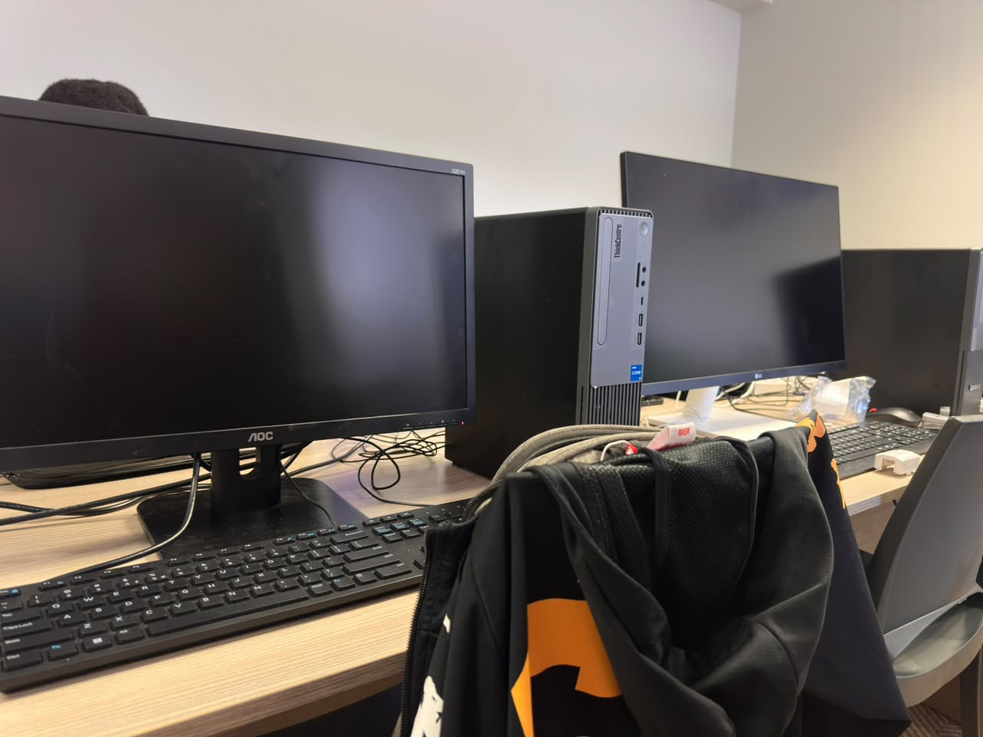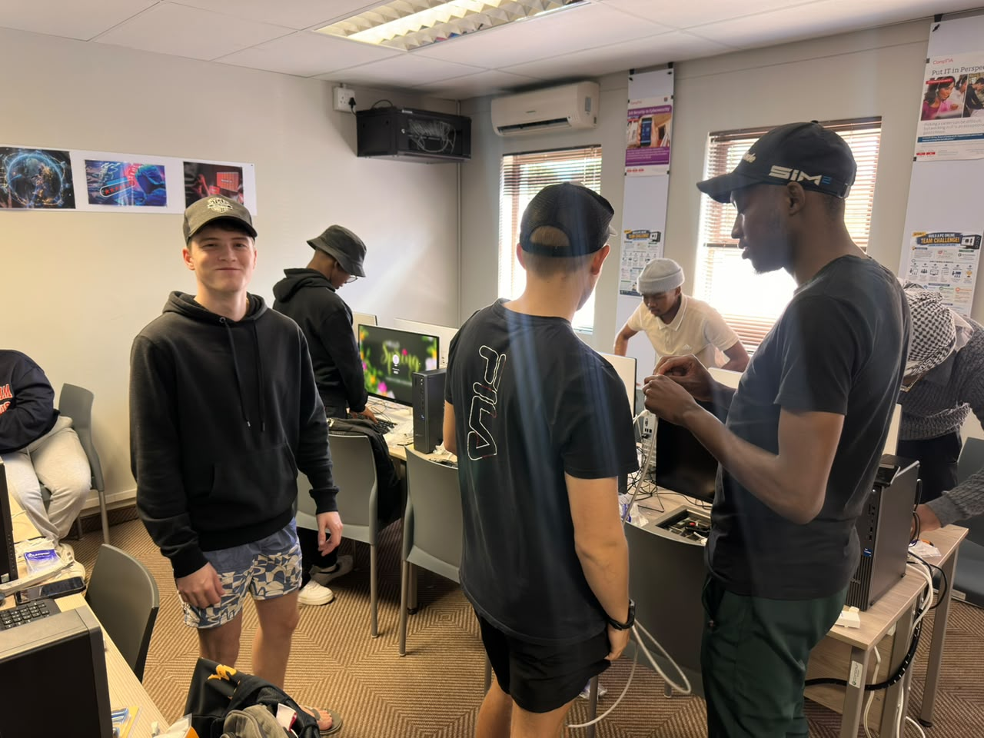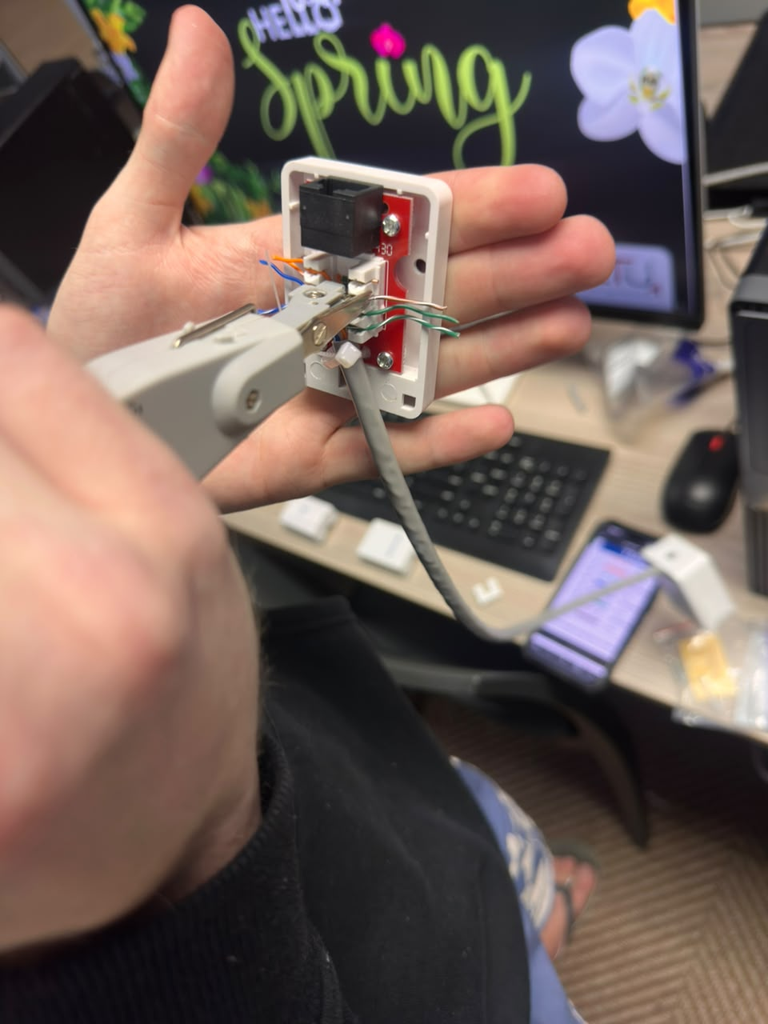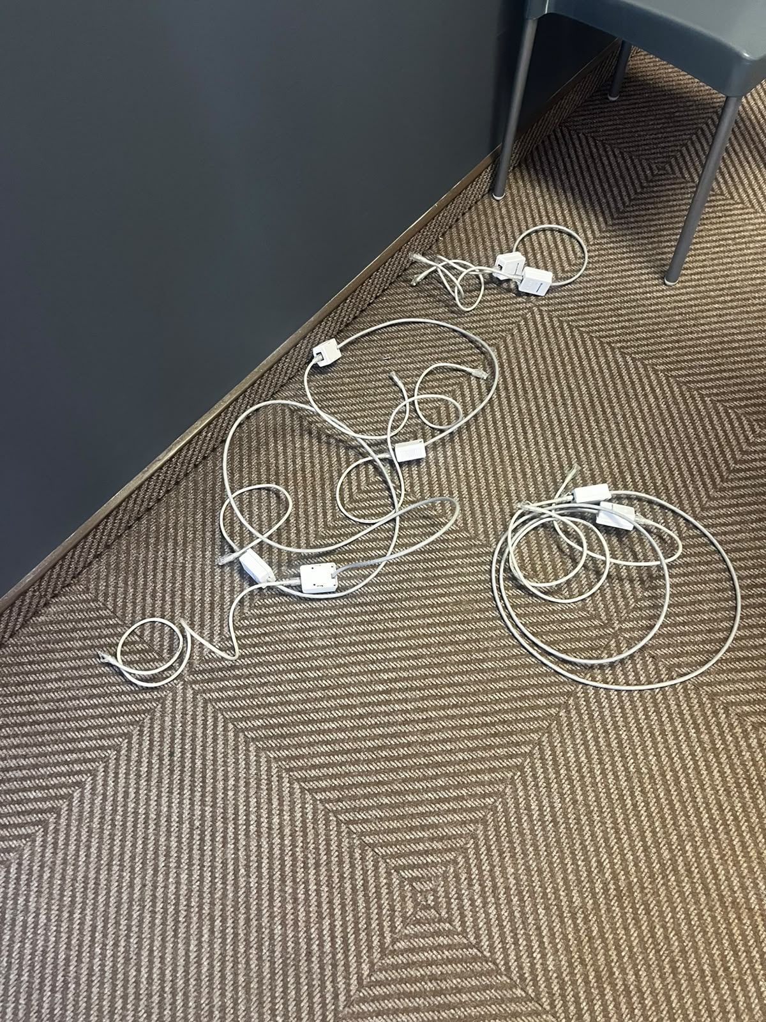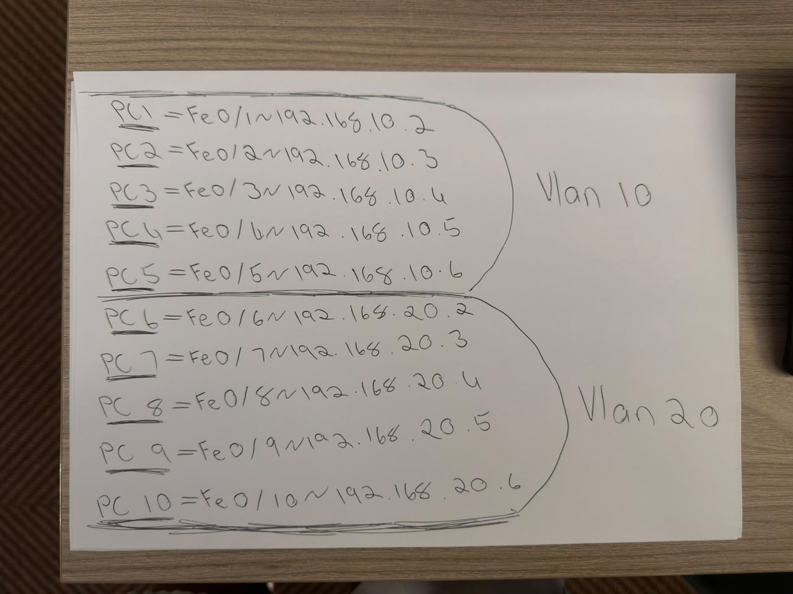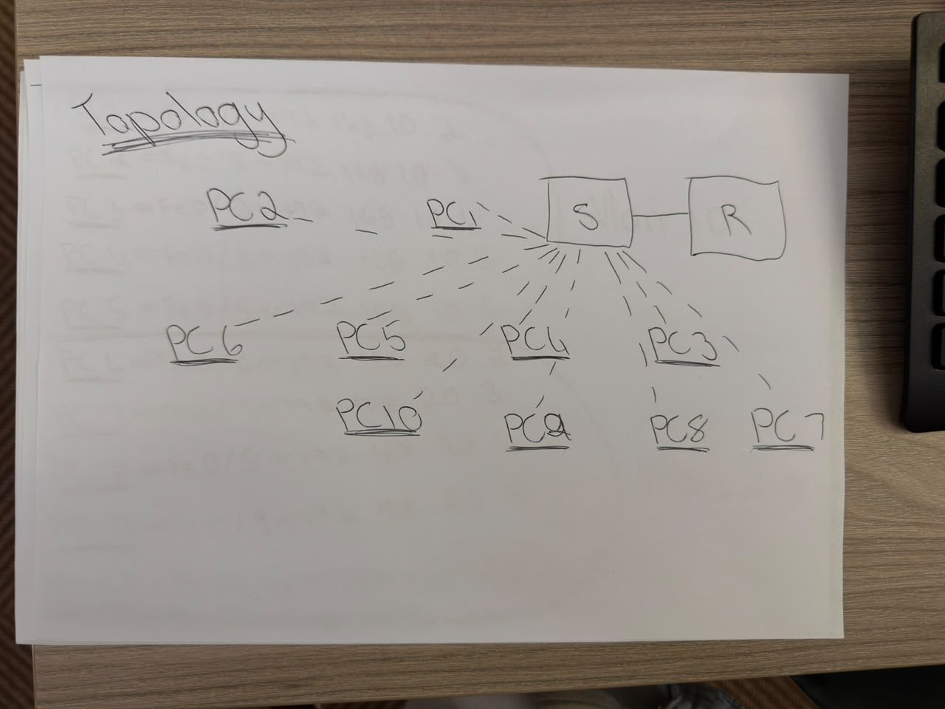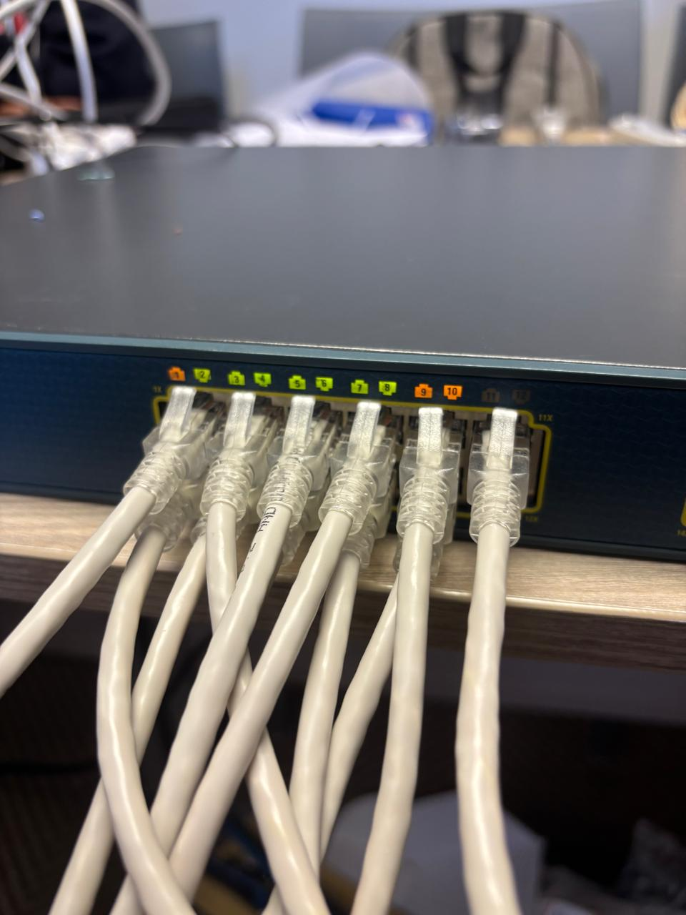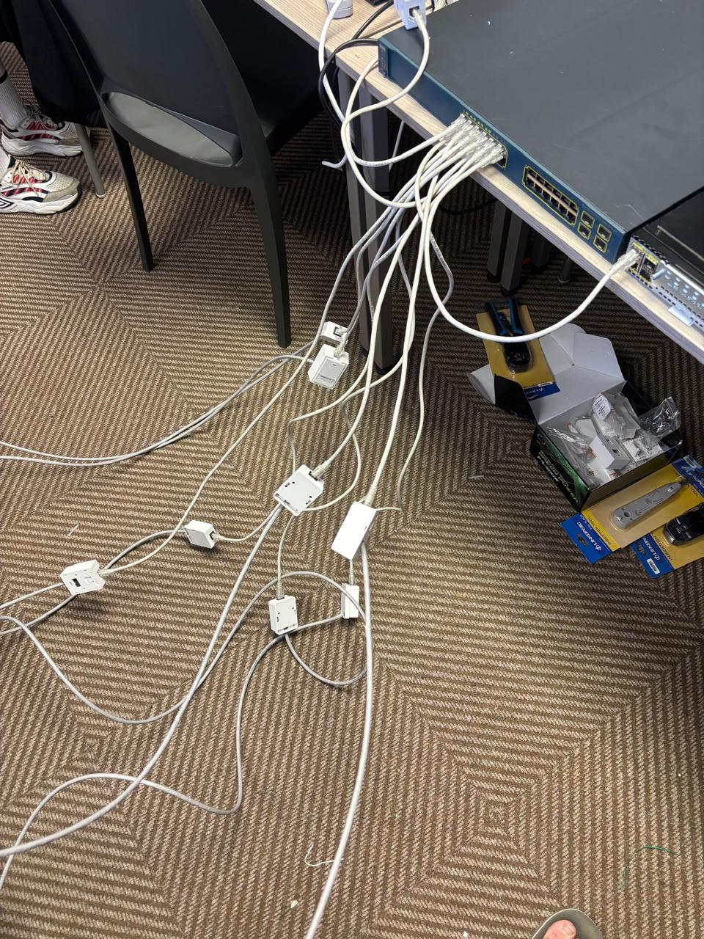
- Install switch cabinet.
- Install patch panels.
- Configure switches.
- Configure routers.
- Implement VLANs.
- Configure printers.
- Test and troubleshoot the network.

Introduced Faults
  - Incorrect VLAN assignment
  - Incorrect subnet mask
  - Incorrect default gateway
  - Duplicate IP address
  - Faulty patch lead
  - Disabled switch port
  - Router interface shutdown
  - Missing route

Troubleshooting Commands
- show running-config
- show vlan brief
- show interfaces
- show ip route
- show ip interface brief
- show mac address-table
- ping
- tracert

Deliverable
Completed troubleshooting report.

Assessment Rubric (10 Marks)

Criteria | Marks
Fault identification | 3
Troubleshooting methodology | 3
Correct resolution | 2
Professional report | 2

10
Total

PRACTICAL OBSERVATION CHECKLIST

Competency | Yes | No
Uses tools safely |  | ☐
Uses crimping tools correctly |  | ☐
Uses punchdown tools correctly |  | ☐
Applies T568B correctly |  | ☐
Configures Cisco devices correctly |  | ☐
Demonstrates troubleshooting skills |  | ☐
Maintains clean workstation |  | ☐
Demonstrates teamwork |  | ☐
Produces accurate documentation |  | ☐

